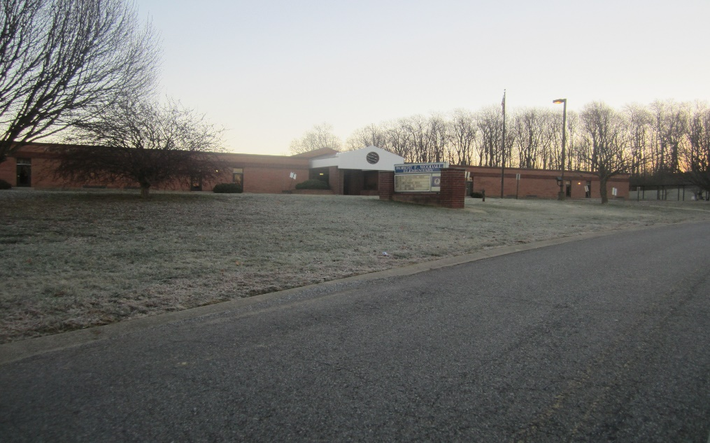
Robert F. Woodall Primary School
White House, Tennessee
Robertson County School System

Prepared By: Jamie L. Marvin
February 2015
Collection Development, MLIS 5080
Trevecca Nazarene University

Abstract
A school library collection should support the academic and curriculum needs of the school while also serving the personal interests of its patrons. A key component to meeting the curriculum needs of a school is to provide materials that are current, and address any shifts in educational reform. This collection analysis and development plan highlights the needs of nonfiction materials at Robert F. Woodall Primary School in White House, Tennessee. A development plan centering on the community, school, and curriculum data was designed. The plan will include a budget outline and potential fundraising efforts to establish strategic goals for immediate needs, as well as long range goals to be met over the next five years.

Collection Analysis & Development Plan
The non-fiction collection at Robert F. Woodall Primary School is comprised of 2,469 books, with the average publication date of 1995. A collection analysis was completed, and the evaluation revealed areas in which curriculum needs were not being adequately met. The two main reasons included a significant number of books that were aged and dated, and a lack of books that met the academic standards for students at Robert F. Woodall Primary. A development plan was created to bring the collection up to date and budgeting concerns were addressed. Increased community awareness and fundraising suggestions were provided to alleviate funding limitations.
Community Description
The community of White House was incorporated in 1971. The current population is close to 11,000. It is racially comprised of 96% Caucasian, 1.5% African American, and 1% Hispanic. It is uniquely positioned between Robertson and Sumner counties, with Highway 31 serving as the dividing line. This suburban community lies approximately twenty one miles north-east of Nashville and has a high commuter workforce. Only 24% of citizens live and work in the community. The unemployment rate is below the national and state average at 5.9%. The average median income for residents in White House is $67,332, and roughly 6% are below the national poverty line. There are three public schools on the Robertson county side, and two private schools. The educational breakdown of residents is provided in the chart on the following page.
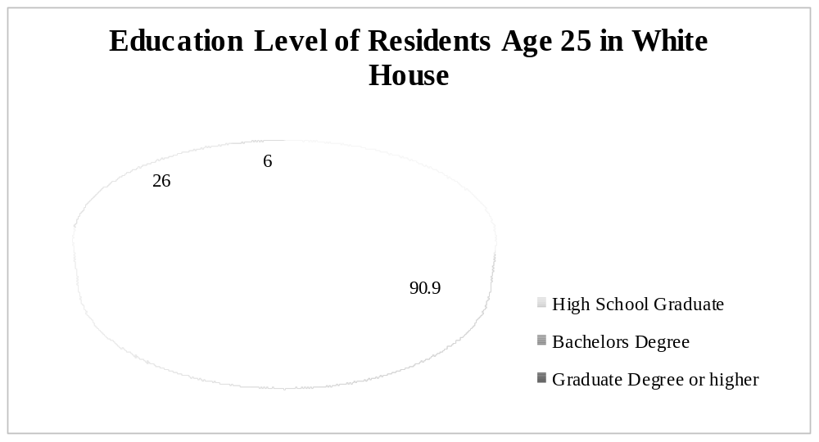

The leading industries in White House include agriculture, manufacturing, healthcare, retail, and governmental/social services. Several new businesses have come to the area in the past two years. Werthan Packaging recently relocated from Nashville and employs over 200 individuals. Other major employers include Lowes Manufacturing, Tate Ornamental, Walmart, and Kroger. All of these employers, and the bulk of retail businesses, are located on the Robertson county side of the White House community.

School Description
Robert F. Woodall Primary School is located in White House, Tennessee on the Robertson County side. Prior to 2005, White House residents shared community schools between Robertson and Sumner counties. With rapid growth, and the need to build more schools, the two districts came to a decision that each county would provide schools for residents on each side of the county line. Woodall was built in 1994 and works with students from prekindergarten through second grade. There are currently 384 students enrolled. It has one preschool class, which serves students with special needs, and seven kindergarten, first, and second grade classrooms. The preschool class has 18 part time students, 132 students are enrolled in kindergarten, 116 in first grade, and 118 in second grade.
It is comprised of one principal, a part-time assistant principal, 30 teachers, and 12 support staff personnel. Dena McRee has served as principal since 2010, when the school became a primary school. The current librarian, Dinah Maupin, recently began serving at Woodall in 2012 as both librarian and assistant principal. The faculty is all female, but there is one male custodian. An ethnic breakdown of the school faculty and student body is provided on the chart below. The student demographics include 38.8% economically disadvantaged, 14.3% with disabilities, and 2.9 % are English language learners. Almost half, 47 percent, of the teachers have a master’s degree or higher. The school does not have any extracurricular activities or student clubs. However, the Parent Teacher Organization, is very active within the school and community; hosting bimonthly meetings at night and special events for students throughout the year. The school does offer use of its facilities, for an annual fee, to a before and after care school program called Patriot Pals.
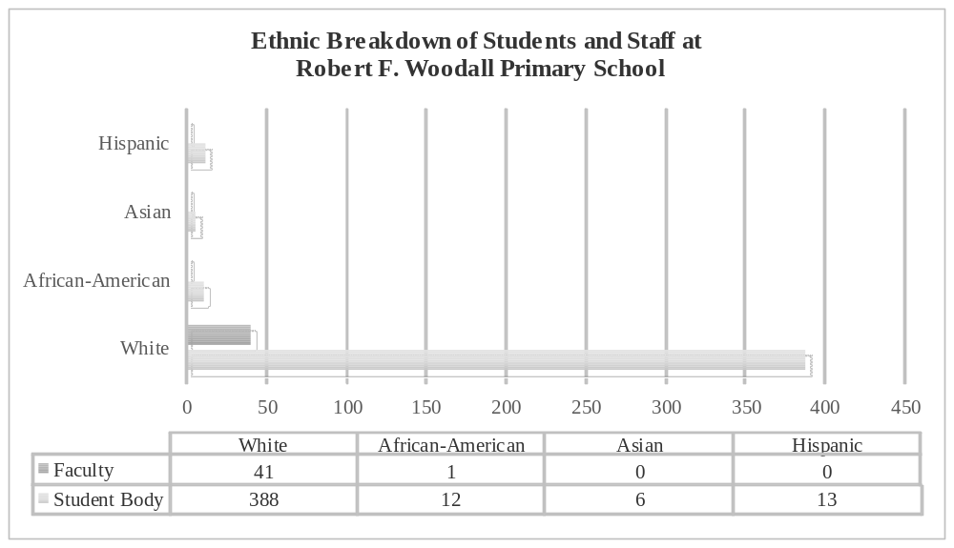

The school is working continuously to improve academic achievement goals and higher technology capabilities. Since it is a primary school, a portion of the school’s evaluation scores come from the feeding school White House Heritage Elementary. Heritage Elementary School’s overall composite TVAAS score is a four, and the value-added grade for 2014 in grades third through eighth were straight As in math, reading, science, and social studies. Woodall Primary also uses the Stanford Achievement Test (SAT 10) for evaluation purposes as well. Last year, student achievement scores from the SAT 10 test were used to develop areas of focus for the current school year. In first grade, 83% of students were proficient in reading and 72% in math. In second grade, 79% of students were proficient in reading and 81% in math.
In the past five years, the school has worked closely with the PTO and Patriot Pals program to upgrade the school’s technology equipment. Each classroom has ceiling mounted projectors with pull down screens, a document camera, teacher workstation computer, iPad, and at least one student computer. There is one computer lab with 25 computers and a new iPad cart with 25 iPads as well. The school can also accommodate large groups of individuals in either the library or cafeteria, depending on the size, with drop screen projectors.
Description of Library
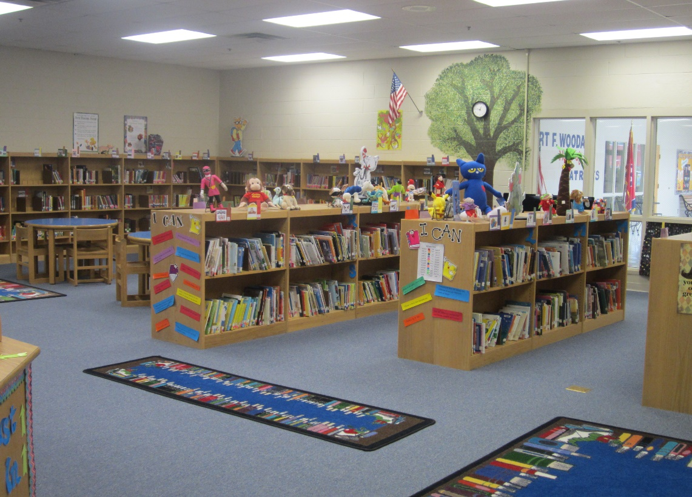
The school library is centrally located within the school. Upon entering the building, one looks directly into the library through glass windows. The library can comfortably accommodate 50 adults with seating. There are ten sets of round tables with four chairs at each table as well as two rectangle tables with four chairs for patron use. The outer walls are lined with shelving, there are three large stand alone bookshelves, and a circulation desk. The library also has connecting doors to two other rooms, which house resource curriculum materials and a professional development room for teachers. The library includes an office that can be used as either a workroom or story room. The current librarian made this room into her office and a story room for the children.
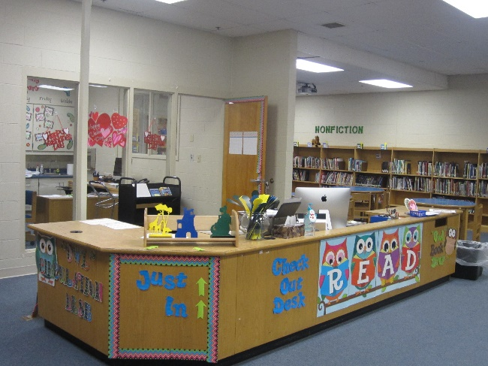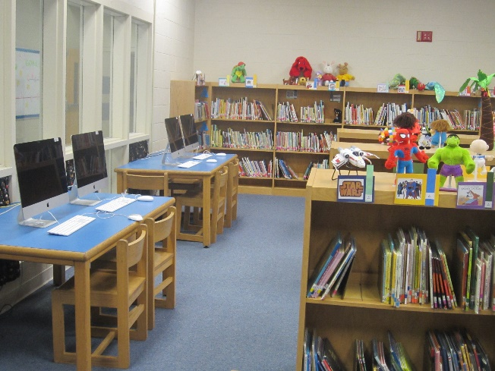
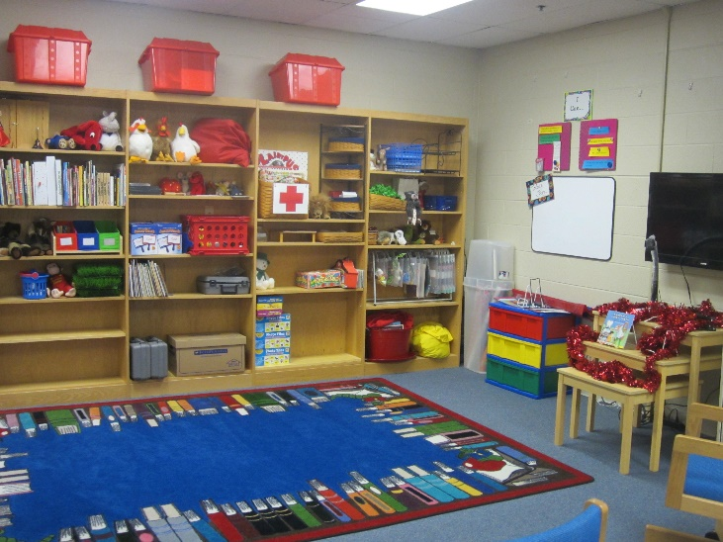
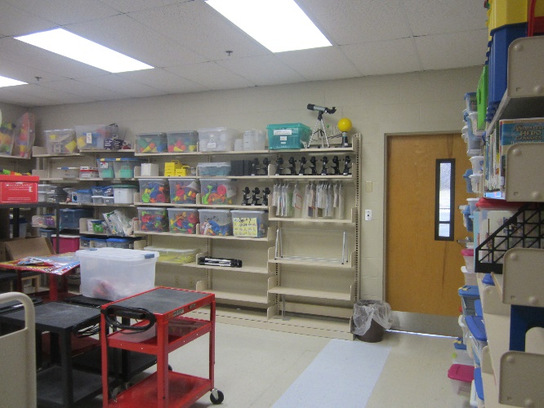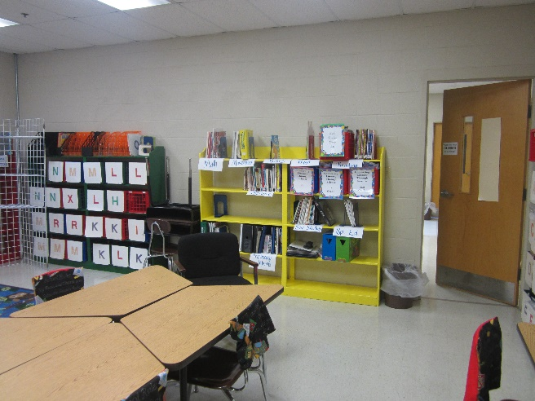
The library has four computers for student use and research. Additionally, one computer is located at the circulation desk, one in the librarian’s office, and one media/teacher computer is on a wall shelf for faculty members and presentations. Across the hall from the library is the computer lab, which is also managed by the librarian. There is one full-time library aide, and one full-time computer instructor to assist the librarian. Most book shelves contain materials, but some are more loosely filled than others. Thus, books can be easily shifted and accessed. The height the of top shelving aroud the walls maybe challenging for some of the preschool and kindergarden students to reach but is age appropriate for first and second graders. The resource room that connects to the back of the library stores DVD collections, listening center books, large books, classroom book sets, and other classroom curriculum materials. Adjacent to this room is the professional resource rooms which houses leveled readers, and personal and professional materials for faculty members.
The library typically stays unlocked, unless the book fair is going on. Teachers may check out materials by completing a form with their name and the bar code if no one is available. The library uses Library World as it’s circulation system. The programs offers various reports such as over-due books, lost and missing books, patrons by grade and usage, and weeding reports as well. Library World is a very basic program, and does not have many options for graphics and could be more user friendly. The program is aligned with Follett’s Titlewave system.
The White House public library is less than one mile for the school Currently, there is no an inter-loan service or joint relationship. The current facility is outdated and severely limited on space. The city of White House is building a new public library and should be open to the community in the spring of 2015. Librarian, Elizabeth Kozlowski, recently graduated from the University of Tennessee and seems eager to expand programs offered by the library. The potential for developing joint services appears to be open for discussion.
Collection Statistics
There are 2,469 non-fiction books in the Robert F. Woodall Library. This represents 26.7% of the collection, which contains 9,249 books for the total collection. The ratio of books to students is six non-fiction books per student and 24 books per student for the entire collection. State requirements entail that a print collection shall average a minium of 12 books or items per student. Items that are out-of-date, damaged, and contained incorrect information should not be reported or included in the total collection count. The following charts reveal a breakdown of the entire collection, then highlight the percentage of books in the nonficiton collection.
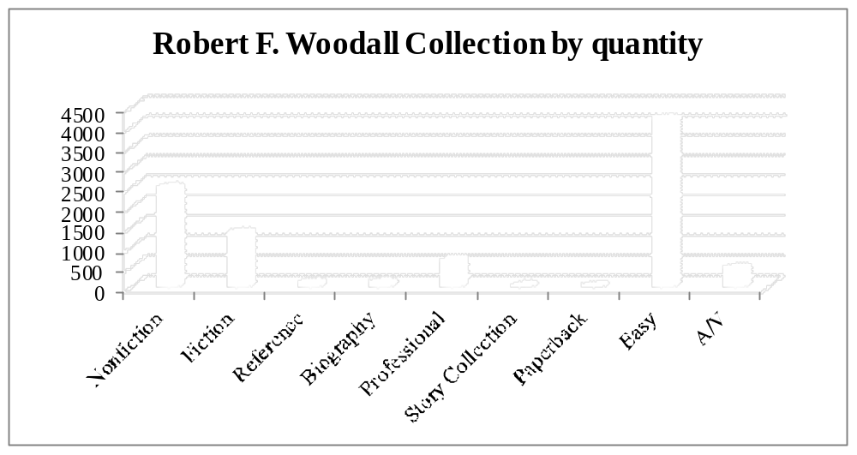

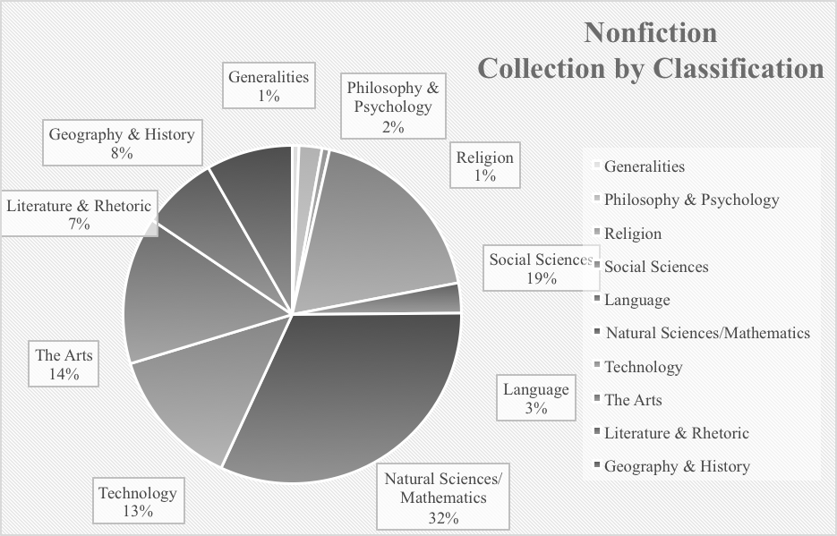

As noted, the school library has double the amount of recommended items to meet state requirements. However, the average age of many of the books reveal there are numerous items that are out-of- date or worn, and need to be discarded. The graph on the following page compares the number of books in the nonfiction collection before weeding and after the recommended weeding.
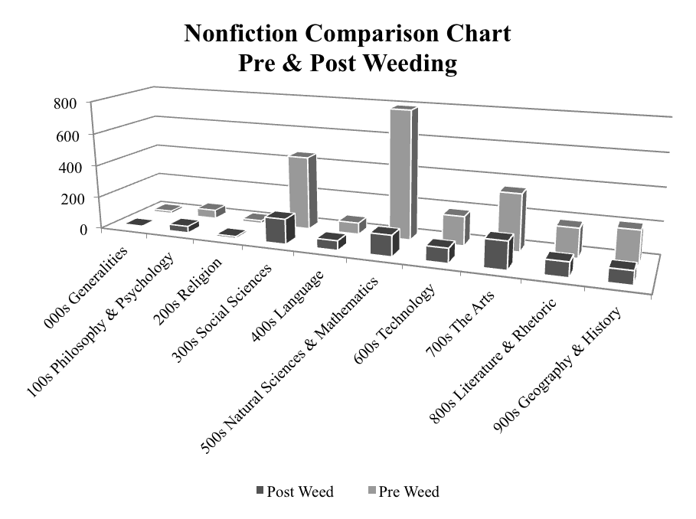
Collection Analysis
Developing a collection analysis involves several steps. To begin, it is important to examine the collection and compare how it can be best used by its patrons. The library in review is a primary school; therefore, the collection should be tailored to the academic and curriculum needs of the students. The collection needs to be current and meet minimal state requirements. Additionally, it should be customized to meet the needs of the community, while also providing a diverse and balanced array of topics and titles.
The nonfiction collection at Robert F. Woodall Primary School, is largely out-of-date and in need of a weed and feed development plan. Since the overall collection has a large quantity of books, an emphasis was placed on the academic needs of the school along with the call for more informational texts with the implementation of Common Core when creating the proposed budget.
The average copyright date of the nonfiction collection is 1996, an average of 19 years old. Thus, a significant number of books should be discarded. With careful consideration, it was determined that 1,645 books should be weeded from the 2,469 collection. Very few recommended books were not marked for discard; these books mostly included topics on natural history and animals. When considering forty books cost an average of $1000, and recent cuts to the district’s library funds, a conservative approach was taken to creating the proposed budget. With this approach and additional fundraising efforts being taken, it is hopeful the minimal budget can be reasonably attained.
To meet the needs of the library, the collection development plan is spread over five years. Immediate action will include discarding all books published prior to 1985. The two areas in need of heavy discarding also align with the academic needs of the school. The two main sections were the 300s Social Sciences and 500s Natural Sciences/Mathematics. These two areas along with the 800s Literature and Rhetoric will be focused on first. The 800s were divided over the first two years because of the need for language materials, which was expressed from a recent teacher survey and SAT 10 scores. Each nonfiction area will be fed back into over the next five years. Therefore, in the collection analysis chart, found in the appendix, each area will be marked with a “-“ sign to indicate weaknesses found. Even with the high quantity of books in the collection, the nonfiction collection as a whole needs to be supplemented.
Along with replacing the discarded materials for certain topics, the collection will be enhanced to fill in the missing gaps of information for certain areas. The three largest gaps included Generalities, Religion, and Language. While these areas are not as curriculum rich as the other fields, it is recommended to invest in. The library is committed, and will strive to meet the needs of all patrons on both an academic and personal level.
Funding
Funding for the school library has been a challenge and source of controversy over the past two years. Last year school library budgets were cut throughout the district. Prior to this, libraries were allotted a budget based on the number of students in the school. The shift in funding coincidently occurred the same year as new district leaders came into office. The current budget designates a $1000 for books. The school also hosts a fall and spring book fair with a family night as well. In recent years sales have been declining, but a minimal income of $1000 is a secure and conservative expectation. Last year the school brought in close to $1,700, but with declining sales a $1,000 guarantee should be expected over the next five years. Any surplus in book fair funds could be used to maintain other collections and cover unforeseen expenses in the coming years.
Additional avenues for funding should also be considered to meet the needs of the school and patrons. One option would be to invite grandparents for lunch one day during the book fair and allow students to shop after their lunch break with their grandparent or special guest. The principal has supported this opportunity in previous years and therefore would be open to offering it again. Additional volunteers would be needed but the payoff would be beneficial. Another avenue to consider is a Birthday Book Club, where individuals donate a book to the library in honor of a student’s birthday. Similar fundraising options would be offered for “in honor of” and “in memory of”. Individuals would have a bookplate placed in the cover of a book to identify who and what the book was donated for. Additionally, students could also participate in fundraising by hosting a hat day or pajama day once a semester. For a small fee of a dollar or two, students could wear pajamas to school and all proceeds would benefit the media center.
Outside of the school, funds could be raised through community partners and donations. Seeking support from local businesses for donations is a viable option. Community stakeholders would be provided with a summary of the need for rich curriculum materials, research into the effectiveness of school libraries, and given a list of needed books. The list of books would be related to their field of expertise. For example, The Farm Bureau would be targeted for agriculture books and banks would be targeted for books related to money. Lastly, the district does support the writing of grants based upon principal approval. Grants are being researched and could provide another possible option for additional funds.
Reflection
The collection analysis and development plan has been a challenging but enlightening experience. I truly have gained a better understanding of the needs and responsibilities of a school librarian. Just as teachers face hurdles with change, so do librarians. The need for new and varied information is continually changing and it is our job to keep abreast of the changes. This experience has also made me eager to collaborate and work with fellow teachers. Without their input, the collection may continue to have missing gaps in it. Teachers need to know and feel they have voice in building the school collection.
In discussing the collection with the current librarian, it was brought to my attention many items were lost when the school split and became a primary school over four years ago. There has been some dispute about the quality of materials left, and some items were returned as recently as last year. Although both schools have strengths and weaknesses it has been an eye-opening experience to see the challenges that arise from change.
The process of analyzing the collection was at times painstaking and frustrating. I truly believe you reap what you sew; if you put in the hard work beforehand the outcome will be worth it when purchasing materials, and the students will reap the benefits. Your collection will be sound and utilized. Departing with materials is challenging because funding is so limited. I now realize those books were once carefully chosen and bought, just as the new materials will be. However, the excitement and joy that comes with sharing new resources will be more than rewarding.

Appendix
Collection Analysis
Aligned to K-5 ELA/Math Common Core Curriculum & NC Essential Standards for All Areas

Robert F. Woodall Primary School
Grades: PreK-2nd Dinah Maupin, Media Specialist Collection Size (BD): 2,496 Nonfiction/9,249 Total
Date: February 2015 Dena McRee, Principal Average Age: 1996 / 19 years old
# Students: 384 Robertson County, District Office Budget: $2000
Books per student (BD): 6 Nonfiction / 24 Total Collection

Area | Holdings | Discard | +/- | Curriculum Gaps / Weak Areas
000s  General Works  # Books: 16 | Avg. Age:  2002 | Most resources over 10 yrs. | -- | Need additional materials in: computer science and general encyclopedia works
100s  Philosophy  # Books: 54 | Avg. Age:  1998 | 20 yrs. Unless sources have other values or reasons to keep (i.e., ghost stories) | -- | Need additional materials in: behaviors, and character education
200s  Religion  # Books: 18 | Avg. Age:  1996 | 20 yrs. Unless award winner or other considerations | _- | Need additional materials in: denominations and other religions
300s  Social Studies  # Books: 455 | Avg. Age:  1992 | Most resources over 10 yrs. | -- | Need additional materials in: Ethnic Backgrounds, Cities/Towns, Neighborhoods/Communities, Voting/Elections, Political Parties, Civics, Community Helpers, Economics (Careers/Jobs, Money, Conservation/Environment), Transportation
394 –  Holidays  # Books: 54  398 – Folklore  # Books: 226 | Avg. Age:  1993  Avg. Age:  1991 | 20 yrs. But use condition of books; keep classics and award winners | -  -  - | Need additional materials in: Significantly outdated materials and could use additional items on multicultural holidays and celebrations
400s  Language  # Books: 71 | Avg. Age:  1996 | Use condition and curricular needs | -- | Need additional materials in: Print & digital Dictionaries, Thesaurus
500s  Pure Science  # Books: 791 | Avg. Age:  1995 | Most resources over 10 yrs. except for plants and animals | -- | Need additional materials in: Probability, geography, matter/energy, electricity, geology, glaciers & icebergs, landforms, habitats, ecosystems  Strength: Large selection of dinosaur books
Area | Holdings | Discard | +/- | Curriculum Gaps / Weak Areas
700s  Fine Arts/Sports  # Books: 349 | Avg. Age:  1998 | 20 yrs. But use condition of books for 700-789; use 10 yrs. In sports (790’s) | -- | Need additional materials in: Music, basketball, football, baseball, gymnastics, hiking/camping, water sports, fishing, hunting
800s  Literature  # Books: 180  Story Collection  # Books: N/A | Avg. Age:  1992  Avg. Age:  N/A | 20 yrs. But use condition of books and relevance to curriculum; keep award winners and classics in good cond. | -- | Need additional materials in: American poetry, American miscellany (joke books), letters and essays
900s  History/Geography  # Books: 204  State History  # Books: 12 | Avg. Age:  1998  Avg. Age:  1999 | Historical works: 20 yrs. Unless historically significant and/or primary source  Geography: 5-10 yrs. | -  -  -  _  - | Need additional materials in: Explorers/discoveries, atlas(es), historical documents/maps/photographs/ interviews, narratives, Canada, Mexico/middle America, all continents
920-921  Biography  # Books: 1 | Avg. Age:  1979 | Collective biography: 20 yrs. unless award winner, historically significant or primary source  Individual biography: 10 yrs. unless… | -  - | Need additional materials in: Significantly limited on the number of biographies, American symbols, American history, and world history books in the collection

© 2014, 1995, Karen R. Lowe
CC = Children's Catalog, Selection Tool, Gr. K-6
BD = Before discarding

Robert F. Woodall Primary School

Proposed Budget Plan
Math and Language Arts Common Core Curriculum & TN Essential Standards
For all other Curriculum Areas: 2015-2020
#/Students: 384 Collection Size (Bks. BD): 2,496 Nonfiction / 9,249 Total
Books Per Child (BD): 6 Nonfiction / 24 Total Average Age: 1996_____ Budget: $1000

 | 2015-2016 | 2016-2017 | 2017-2018 | 2018-2019 | 2019-2020
Targeted Areas for Resource Development in the Media Center | 300s Social Sciences  General science, Prejudices, Finance/Money, Transportation,  Land Economics & Conservation, Social Welfare, School Management/ Special Education, Metrology, Government & States, Civil Rights, Fantasy & Folklore  800s Literature and Rhetoric  Literature, Rhetoric, Poetry | 500s Natural Sciences & Math  Mathematics, Astronomy, Physical Science, Geology, Landforms & Oceanography, Rocks & Minerals, Fossils, Plant Growth, Biology/ Environment  800s Literature and Rhetoric  English Literatures | 600s Technology  Medical Science,  Engineering & Allied Operations, Agriculture, Chemical Engineering, Manufacturing  700s The Arts  Civic and Landscape Art, Architecture, Music, Recreational and Performing Arts | 900s Geography and History  World history, Geography,  Maps, American history, Europe, Antarctica, Asia, Africa, Australia, South America  000s General Works  Computer Science, Organizations & Museums, Biographies | 100s Philosophy & Psychology  Knowledge/Ethics, Emotions & Feelings, Coping  200s Religion  Religion, Philosophy of Religion, Christianity, Comparative Religion  400s Language  Language, Linguistics, English, Spanish
Minimum Needed for Replacement and Filling Gaps***$ | $4,112  *Average of 164 new titles | $4,112  *Average of 164 new titles | $4,112  *Average of 164 new titles | $4,112  *Average of 164 new titles | $4,112  *Average of 164 new titles
Current State /Local Media Funds and others: book fairs, PTSO etc. | $2,000 | $2,000 | $2,000 | $2,000 | $2,000
Minimum Budget for Building Exemplary** Media Collection | $8,225  *Average of 329 new titles | $8,225  *Average of 329 new titles | $8,225  *Average of 329 new titles | $8,225  *Average of 329 new titles | $8,225  *Average of 329 new titles
Total (required additional funds) | -$2,112 | -$2,112 | -$2,112 | -$2,112 | -$2,112
(MNPS): $7.50 per child for books ** Exemplary collection = 20-30 bks. Per child ***$1000 = 40 books (estimate) or 1 book = $25 / BD = Before discarding

Robert F. Woodall Primary School

Resource Development Plan
Aligned to K-5 ELA/Math Common Core Curriculum & NC Essential Standards for All Areas
2015-2020

#/Students: 384 Collection Size (Bks. BD): 2,496 Nonfiction / 9,249 Total
Books Per Child (BD): 6 Nonfiction / 24 Total Average Age: 1996 Budget: $1000

2015-2016 | 2016-2017 | 2017-2018 | 2018-2019 | 2019-2020
300s Mathematics & Social Sciences  300 Sociology  301.3 Prejudice/ Propaganda  332 Finance/Money  321 Government & States  323.4 Civil Rights/ Liberty  333 Land Economics & Conservation  362 Social Welfare  370 Education  385 Transportation  389 Metrology  800s Literature and Rhetoric  808 Rhetoric  811 American Poetry  812 American Drama  813 American Fiction | 500s Natural Science & Mathematics  510 Mathematics  520 Space Science  530 Physical Science  549 Rocks & Minerals  551 Geology  551.4 Landforms & Oceanography  562 Fossils  574 Biology/ Environment  581 Plant Growth  800s Literature and Rhetoric  814 American Essays  815 American Speeches  816 American Letters | 600s Technology  608 Inventions  614 Prevention of Disease  616 Diseases  620 Engineering  628 Municipal Engineering  629 Transportation  630 Agriculture  638 Insect Culture  660 Chemical Technology  670 Manufacturing  700s The Arts  709 Art History  710 Civic & Landscape Art  720 Architecture  780 Music  796.35 Basketball  796.33 Football  796.35 Baseball | 900 Geography & World History  909 General World History  910 Geography  912 Maps/Atlases  920 Collective Biography  940 Europe  950 Asia  960 Africa  980 South America  998 Arctic Islands  000s Generalities  001.6 Computers  005 Computers  010 Bibliographies  060 Organizations & Museums | 100s Philosophy & Psychology  120 Knowledge  152 Emotions/ Feelings  158 Coping  200s Religion  200 Religion  230 Christian Theology  290 Comparative  Religion  400s Language  400 Language (General Topics)  410 Linguistics  423 English Dictionaries  490 Other Languages
* Discretionary –Nonbook and/or flexible funds © 2012, 1995, Karen R. Lowe
CC = Children’s Catalog (Wilson) BD = Before discarding
MJHC = Middle and Junior High Catalog (Wilson)
SHC = Senior High Catalog (Wilson)

